**Exp - 3 Represent all entities and relationships in a tabular fashion(Relational Model)**

**E-R Diagram for E-Commerce**

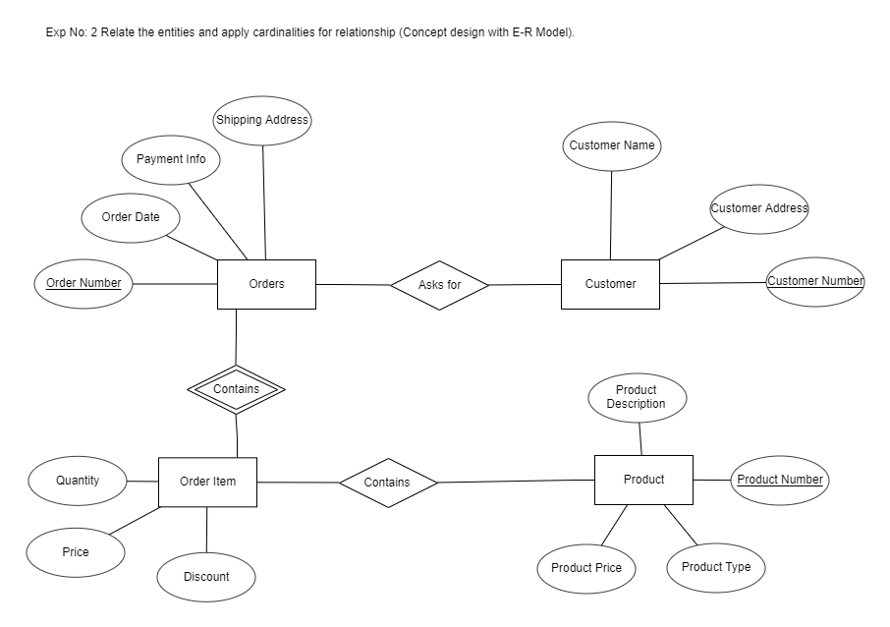

**Orders: Customer:**

|  |  |  |
| --- | --- | --- |
| **Column Name** | **Data Type** | **Constraint** |
| **Order Number** | **Integer** | **Primary Key** |
| **Order Date** | **Date** |  |
| **Payment Info** | **Integer** |  |
| **Shipping Address** | **Varchar(50)** |  |

|  |  |  |
| --- | --- | --- |
| **Column Name** | **Data Type** | **Constraint** |
| **Customer Number** | **Integer** | **Primary Key** |
| **Customer Name** | **Varchar(20)** |  |
| **Customer Address** | **Varchar(50)** |  |

**Order Item: Product:**

|  |  |  |
| --- | --- | --- |
| **Column Name** | **Data Type** | **Constraint** |
| **Price** | **Decimal** |  |
| **Quantity** | **Integer** |  |
| **Discount** | **Decimal** |  |

|  |  |  |
| --- | --- | --- |
| **Column Name** | **Data Type** | **Constraint** |
| **Product Number** | **Integer** | **Primary Key** |
| **Product Type** | **Varchar(20)** |  |
| **Product Description** | **Varchar(50)** |  |
| **Product Price** | **Decimal** |  |
| **Result** | **Varchar(50)** |  |